THE WORLD OF WINE
Wine Quality Analysis
Exploratory Data Analysis of Red and White Wines
EDA Project • Group 3
2026

1. Introduction
For this project, we used Exploratory Data Analysis (EDA) to understand what the red and white wine datasets look like and what factors are connected with wine quality. We looked at properties such as acidity, sugar, chlorides, sulphates, density and alcohol. Along with the numerical analysis, we used graphs to make the patterns easier to see.

2. Objectives
- Understand what is inside the wine datasets and how the data is structured.
- Check the datasets for missing values and duplicate records before starting the analysis.
- See how the wine quality scores are distributed.
- Compare red and white wine using basic statistical measures.
- Look at how different wine properties are related to quality.
- Find the variables that show stronger relationships with the quality score.

3. Dataset Description
We worked with two CSV files: winequality-red.csv and winequality-white.csv. Each dataset contains measurements such as acidity, residual sugar, chlorides, sulphur dioxide, density, pH, sulphates and alcohol, along with a quality score. Having separate red and white datasets also makes it possible to compare their patterns.
Measure | Red Wine | White Wine
Original records | 1599 | 4898
Variables | 12 | 12
Duplicate records | 240 | 937
Records after duplicate removal | 1359 | 3961
Average quality | 5.623 | 5.855

4. Data Preprocessing
First, we checked both datasets for missing values and duplicate rows. There were no missing values in the supplied data. We found 240 duplicate rows in the red wine dataset and 937 in the white wine dataset, and these duplicates were removed before the combined analysis.

5. Exploratory Data Analysis
Figure 1. Red Wine Quality Distribution
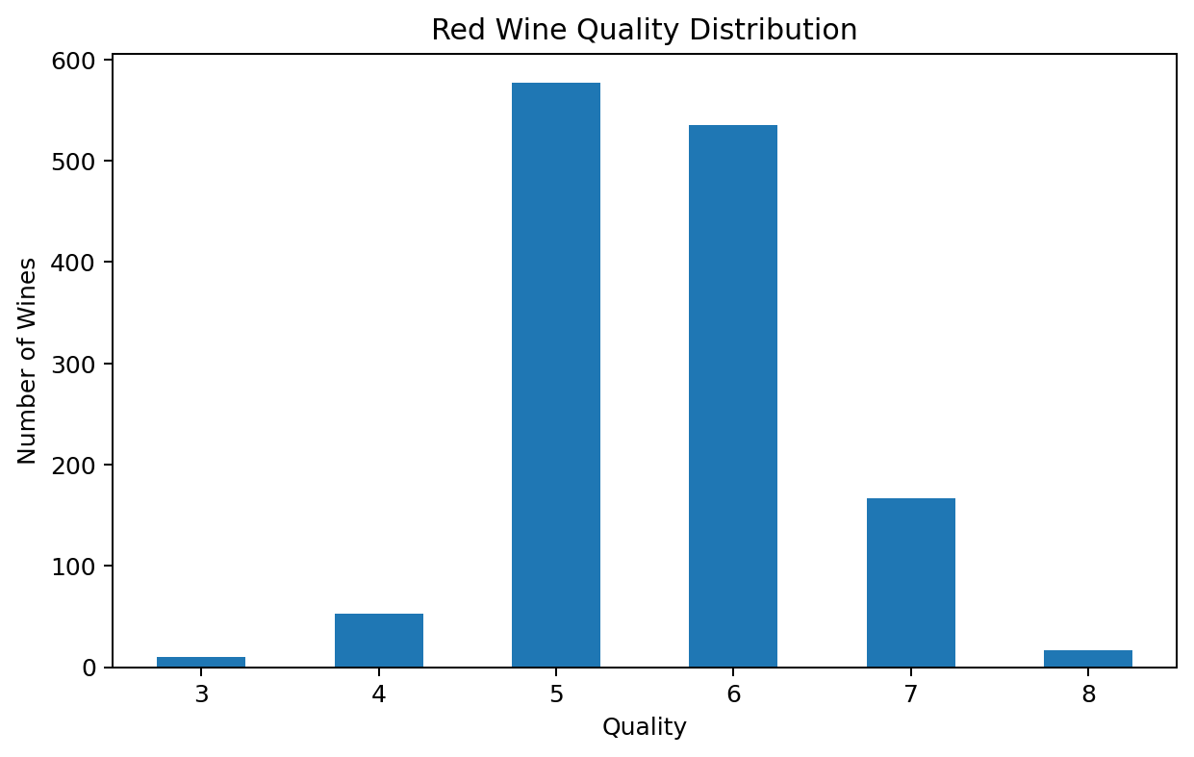
Most of the red wine samples have quality scores around 5 and 6. Only a small number of wines fall at the very low or very high ends of the quality scale.
Figure 2. White Wine Quality Distribution
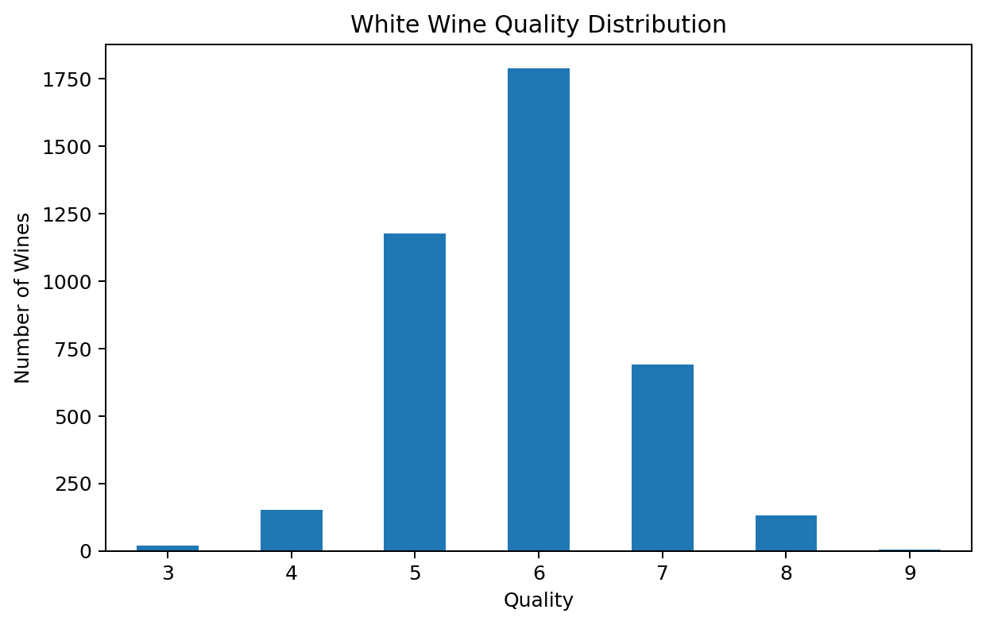
The white wine data shows a similar pattern. Quality scores 5 and 6 make up most of the observations, while the extreme scores are much less common.
Figure 3. Red Wine Feature Distributions
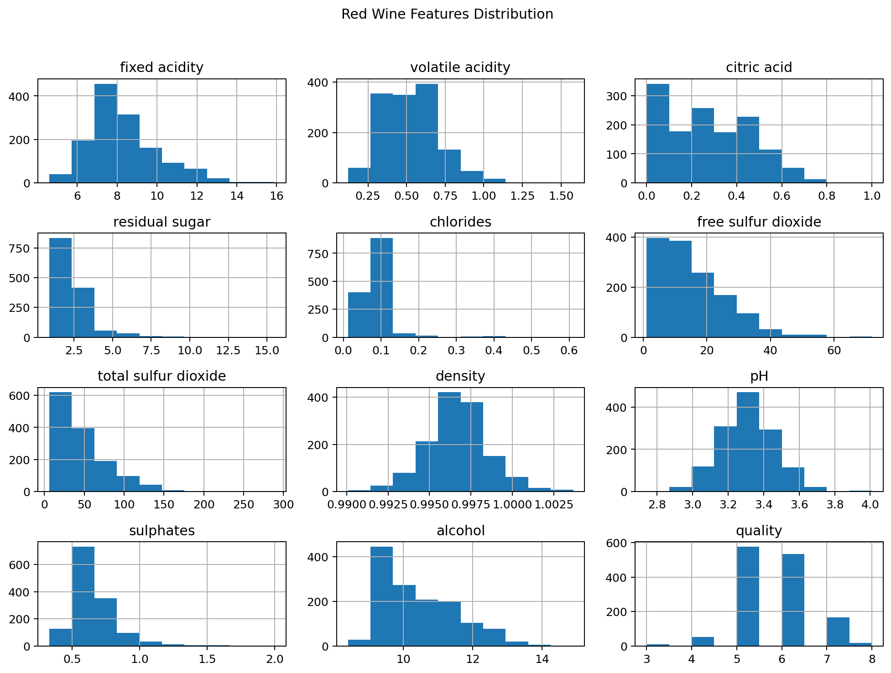
These histograms give a quick look at how the different red-wine measurements are spread. Some variables are tightly grouped, while others have a wider range and noticeable skew.
Figure 4. White Wine Feature Distributions
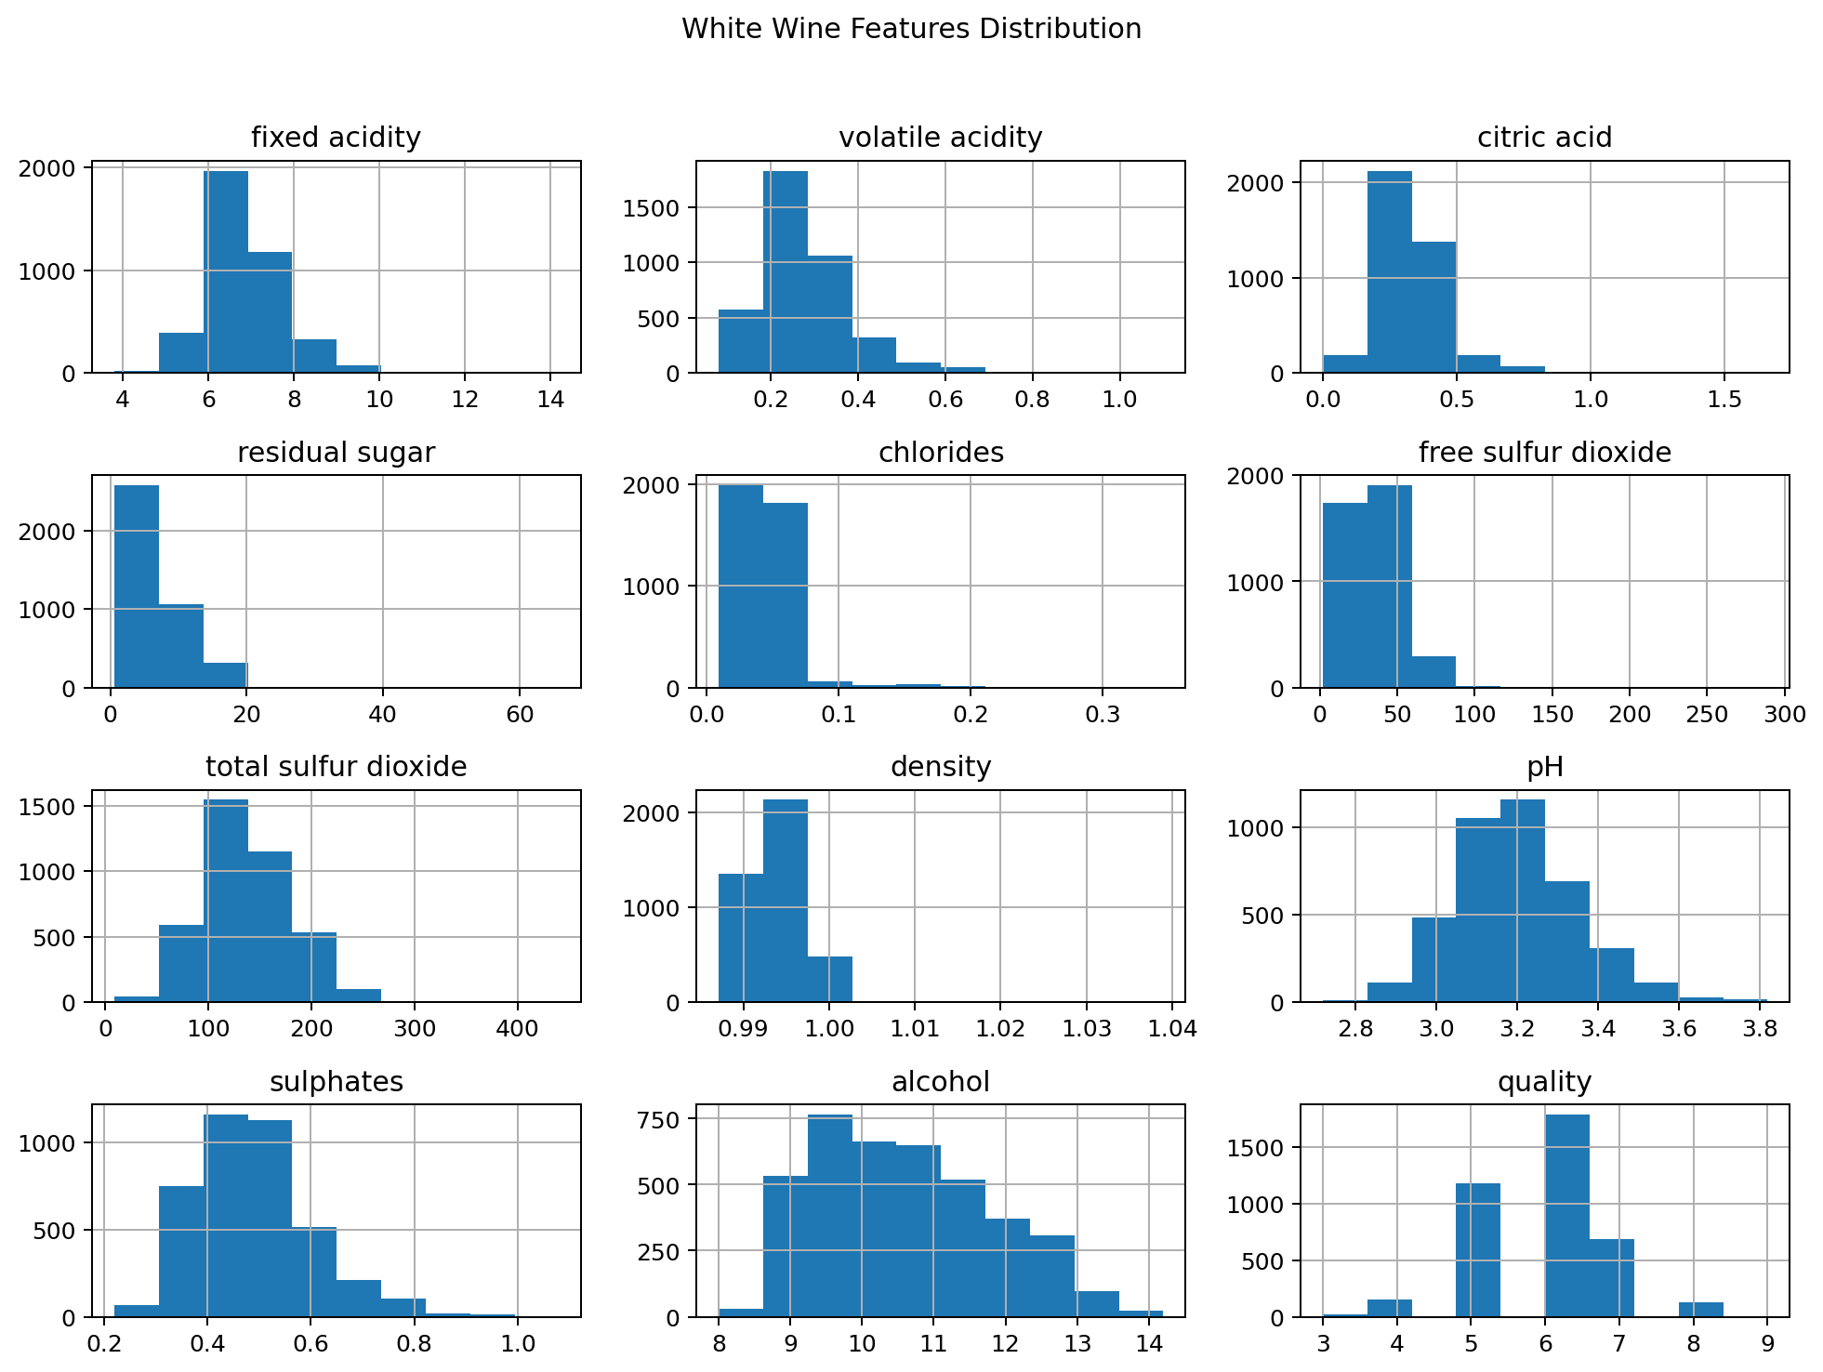
The white-wine histograms show the spread of its physicochemical measurements. The shapes of the distributions are different for different variables, which is useful when comparing the two wine types.
Figure 5. Red Wine Correlation Matrix
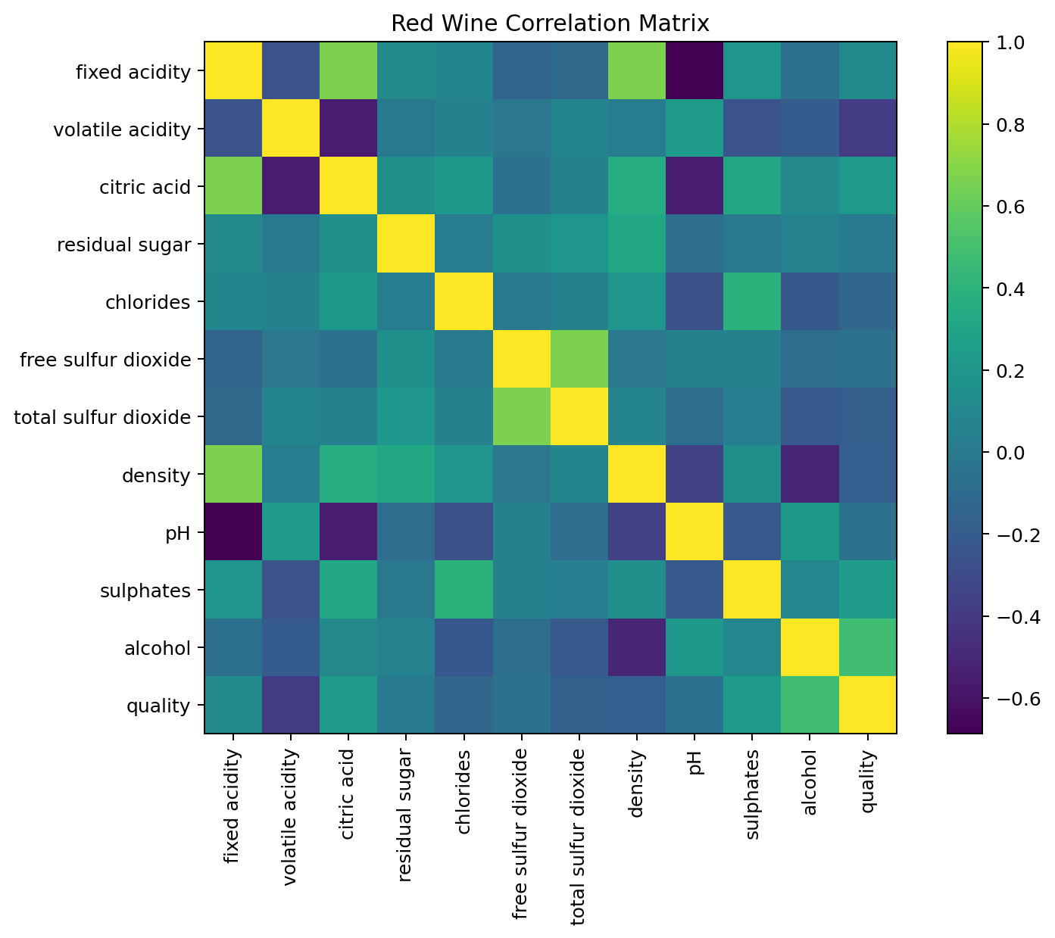
This correlation matrix helps us see which numerical variables in the red wine data tend to move together. Both positive and negative relationships can be spotted from the matrix.
Figure 6. White Wine Correlation Matrix
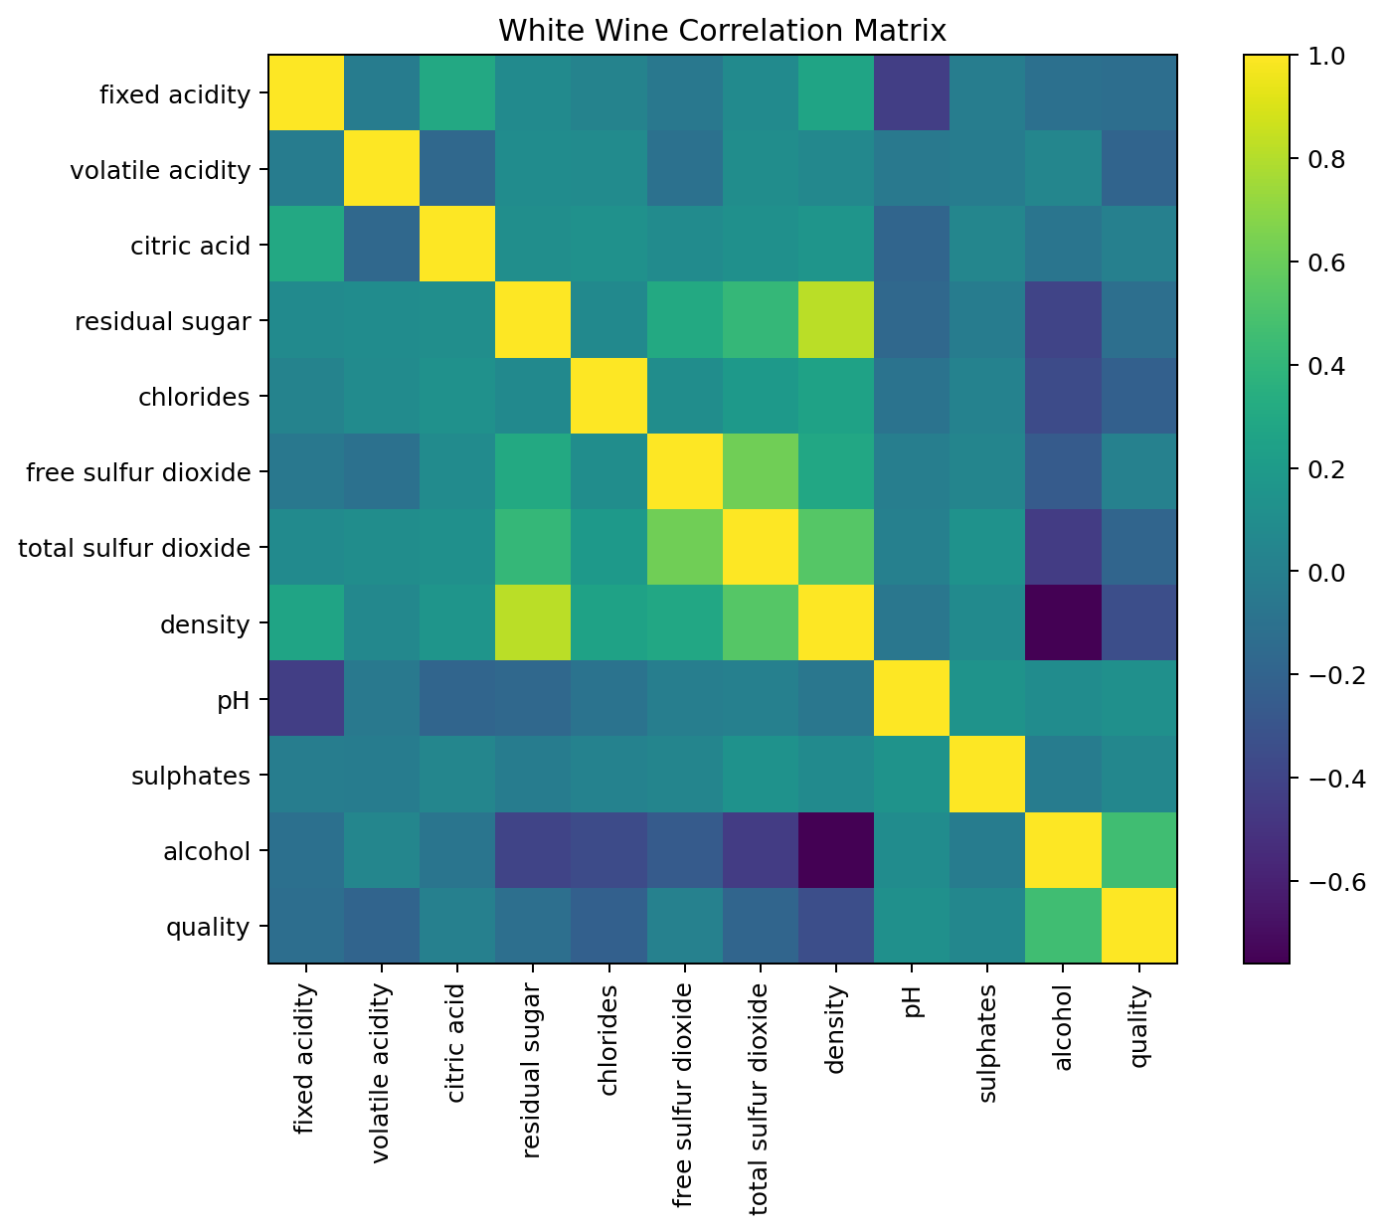
The white wine correlation matrix gives the same kind of overview for the white wine variables and makes the stronger positive and negative relationships easier to compare.
Figure 7. Average Quality: Red vs White Wine
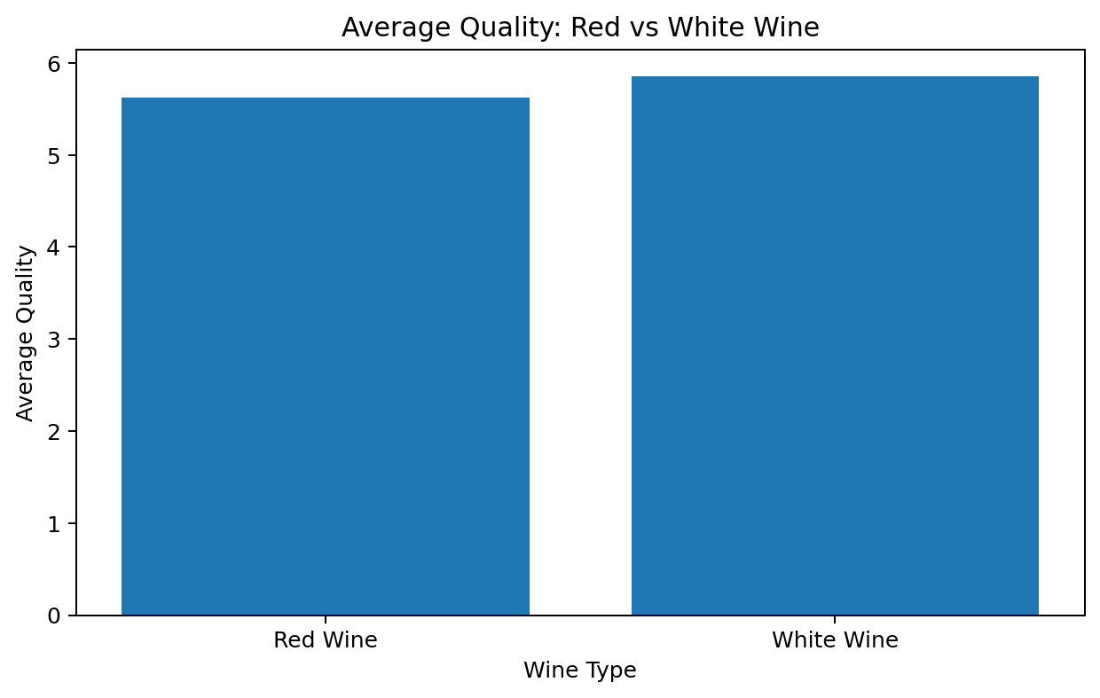
After cleaning the data, the average quality is 5.62 for red wine and 5.85 for white wine. So, the white wine dataset has a slightly higher average quality score.
Figure 8. Average Alcohol Content by Quality
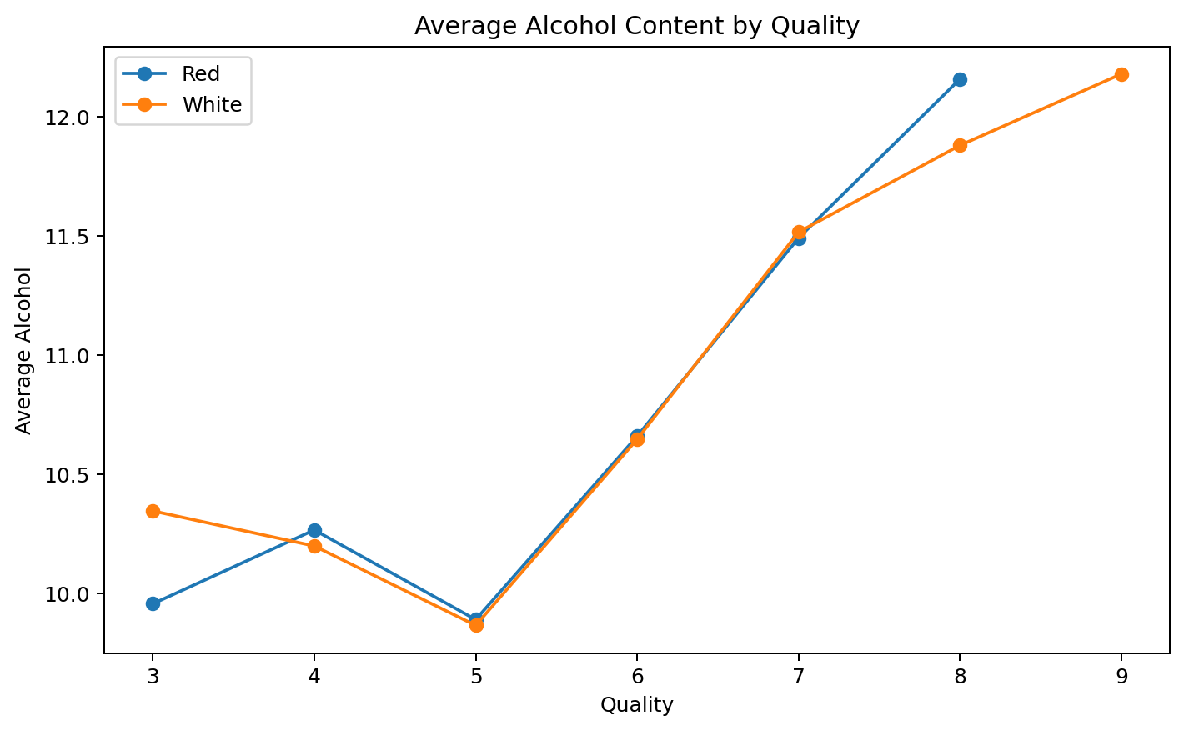
The graph shows that average alcohol content generally becomes higher as the quality score increases. This suggests a positive relationship between alcohol and quality in this dataset.
Figure 9. Average Volatile Acidity by Quality
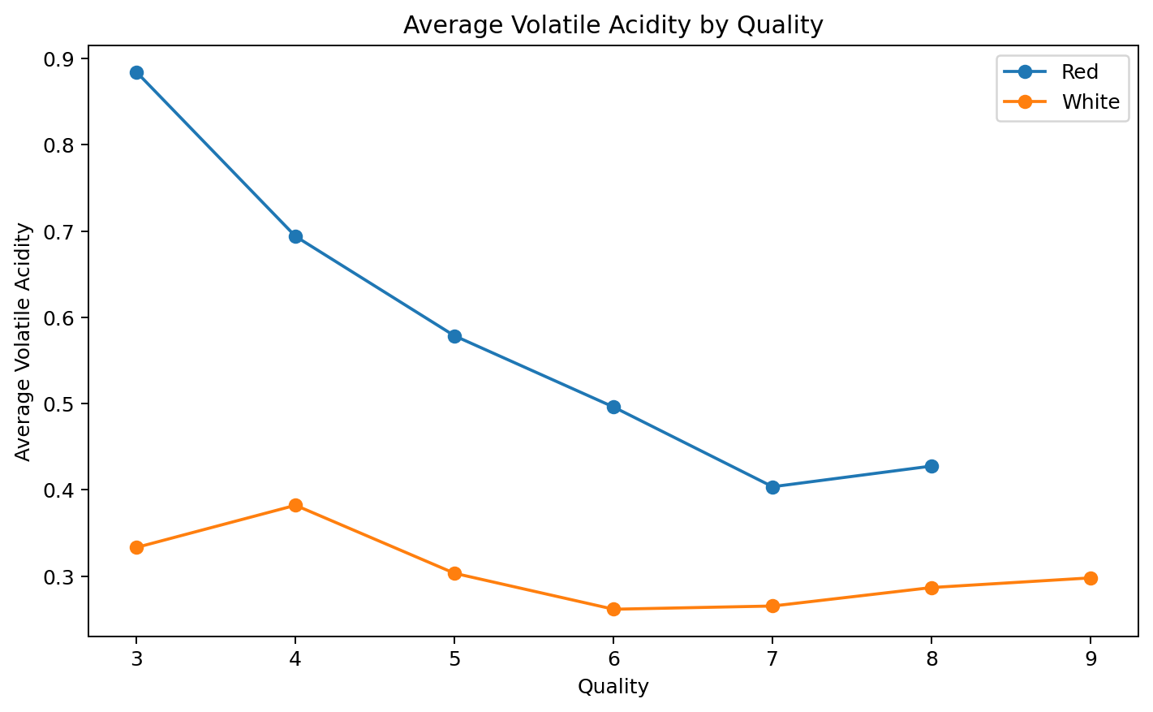
Average volatile acidity generally becomes lower at the higher quality levels. This matches the negative relationship seen between volatile acidity and quality.
Figure 10. Average Density by Quality
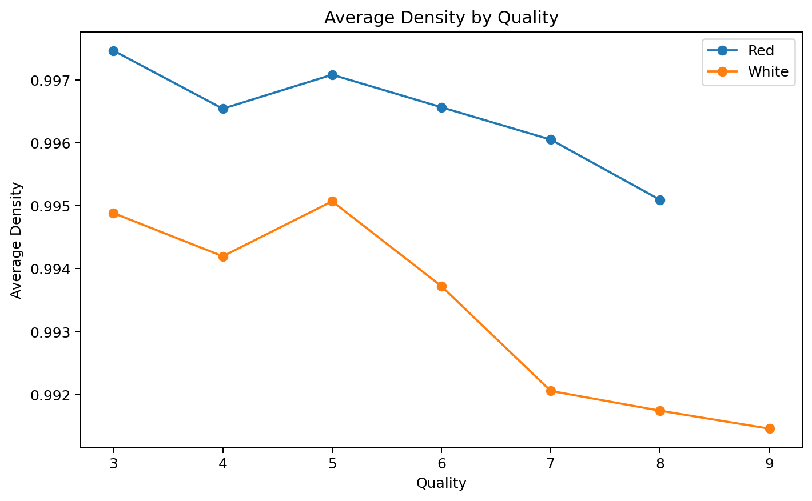
Average density tends to be lower for the higher-quality groups. This is in line with the negative correlation between density and quality found in the analysis.

6. Statistical Analysis
After removing duplicate rows, the combined dataset has 5,320 records and 13 columns, including the wine_type column added for comparison. The quality score has a mean of 5.80, a median of 6, and ranges from 3 to 9.
Quality counts in the cleaned combined dataset:
- Quality 3: 30 wines
- Quality 4: 206 wines
- Quality 5: 1752 wines
- Quality 6: 2323 wines
- Quality 7: 856 wines
- Quality 8: 148 wines
- Quality 9: 5 wines

7. Correlation with Quality
- alcohol: 0.469
- citric acid: 0.098
- free sulfur dioxide: 0.054
- sulphates: 0.042
- pH: 0.040
- total sulfur dioxide: -0.050
- residual sugar: -0.057
- fixed acidity: -0.080
- chlorides: -0.202
- volatile acidity: -0.265
- density: -0.326
In the cleaned combined dataset, alcohol has the strongest positive correlation with quality at 0.469. Density has the strongest negative correlation at -0.326, followed by volatile acidity at -0.265. These values show association between the variables, but they do not prove that one variable causes a change in quality.

8. Red Wine vs White Wine
After duplicate removal, there are 1,359 red wines and 3,961 white wines. Their average quality scores are 5.62 and 5.85 respectively. Since the two datasets have different numbers of samples and different feature distributions, it is better to look at both the averages and the individual distributions when comparing them.

9. Key Findings
- The original combined dataset contains 6497 records; 5320 remain after duplicate removal.
- No missing values were found in the supplied red or white wine datasets.
- Quality ratings are concentrated mainly around 5 and 6.
- The mean quality of the cleaned combined dataset is 5.80.
- Alcohol shows the clearest positive linear association with quality among the measured variables.
- Density and volatile acidity show negative linear associations with quality.
- Red and white wines show different feature distributions and should be compared using their separate distributions as well as overall averages.

10. Conclusion
Overall, this project helped us see how EDA can be used to understand a real dataset instead of looking at numbers separately. The analysis shows that several wine properties are associated with quality. Alcohol has a positive relationship with quality, while density and volatile acidity show negative relationships. The graphs made these patterns much easier to notice and compare between red and white wine.

11. Tools and Technologies
- Python
- Pandas
- Matplotlib
- CSV datasets
- Microsoft Word

12. References
Wine Quality datasets: UCI Machine Learning Repository / original wine-quality datasets.
Python documentation and Pandas/Matplotlib documentation for data analysis and visualization.

